Intro to UE4

**Section 1 – Creating a new project**

Open up Epic Games Launcher

Launch Unreal Engine 4.17.2

Select New Project tab, make sure it is set to C++ not Blueprint, Select First Person Template, select “With Starter Content” from the dropdown, give it a name then press “Create Project”.

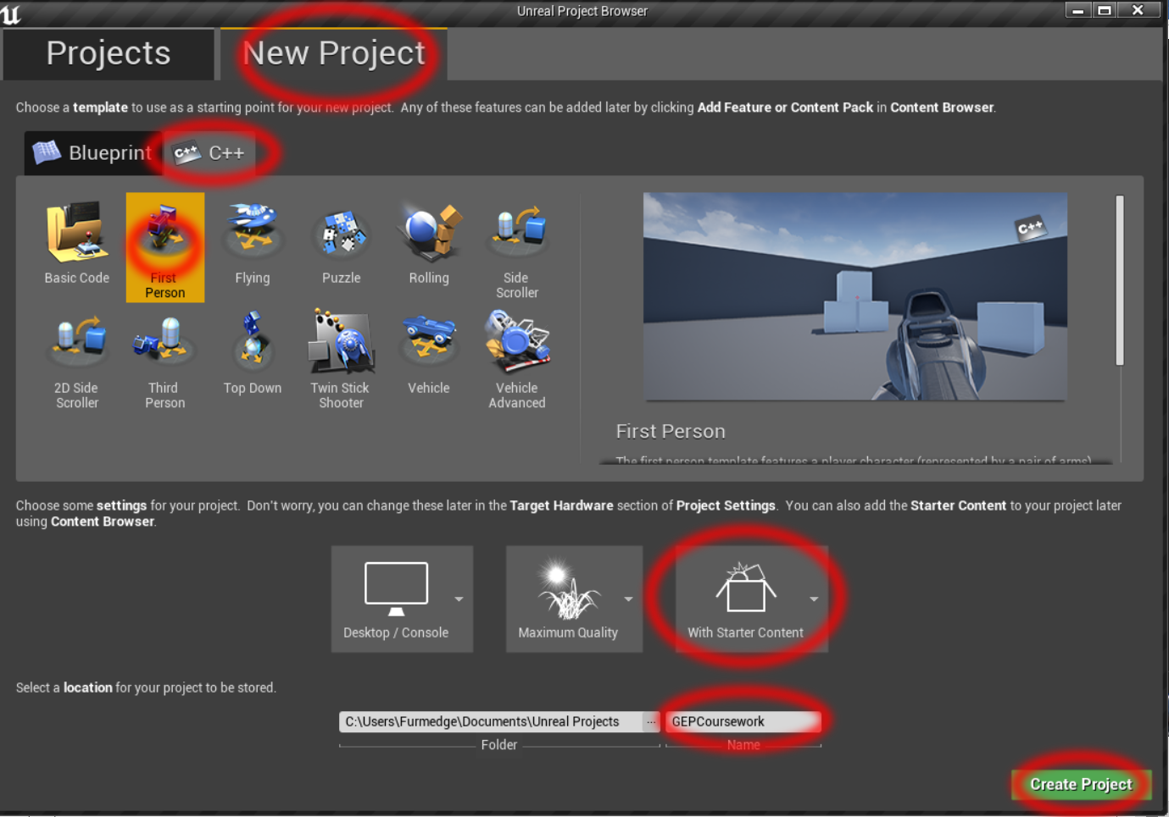

Visual studio and the UE4 editor window should open.

**If Visual Studio does not launch**

1. If you are positive you selected C++ project not Blueprint do step 2, else delete the project and create a new one.
2. Go to the directory folder and see if there is a .sln file, if not right click on the .uproject and select Generate Visual Studio Project Files. Then open the .sln file.

**If the UE4 editor window does not open**

1. Wait for Visual Studio to parse files (shown in purple bar at bottom of screen) then press F7 to compile.
2. Once its compiled it should open the UE4 editor window.

**Section 2 - Familiarize yourself with the editor**

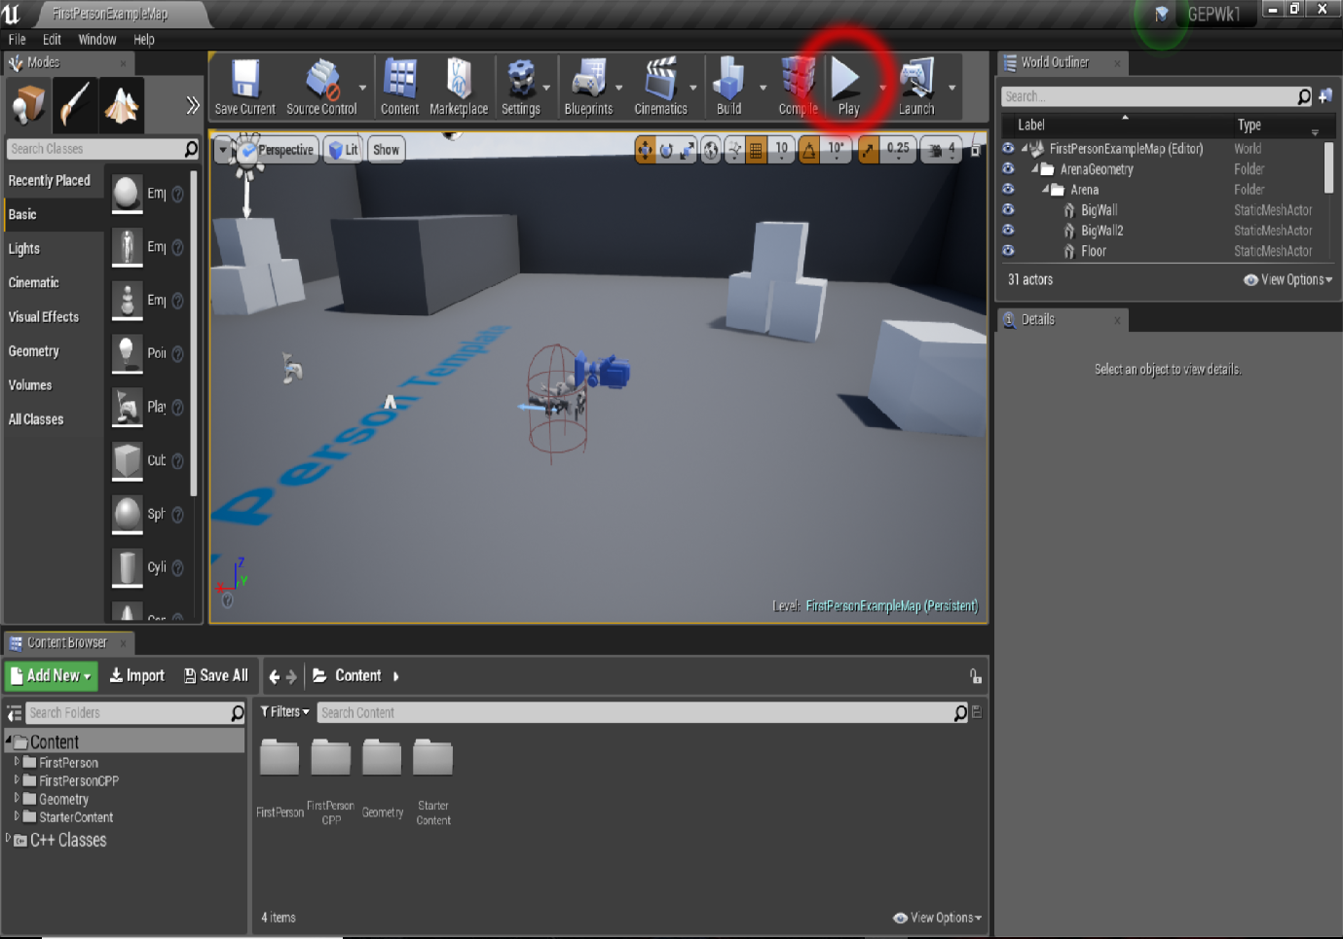

* The right panel is your World Outliner – essentially your hierarchy in Unity
* The bottom panel is your Content Browser – Project panel in Unity
* You can navigate around the scene with the mouse and arrow keys

Once you have familiarized yourself (don’t worry I will explain the rest as I need to) press the play button indicated.

You should be able to shoot with left mouse and move with WASD.

Press Esc to end play mode.

**Section 3 – Adding an explosion when the projectile hits something.**

Bring up visual studio.

Expand the selection in the Solution Explorer and open the files ending in Projectile.cpp and Projectile.h

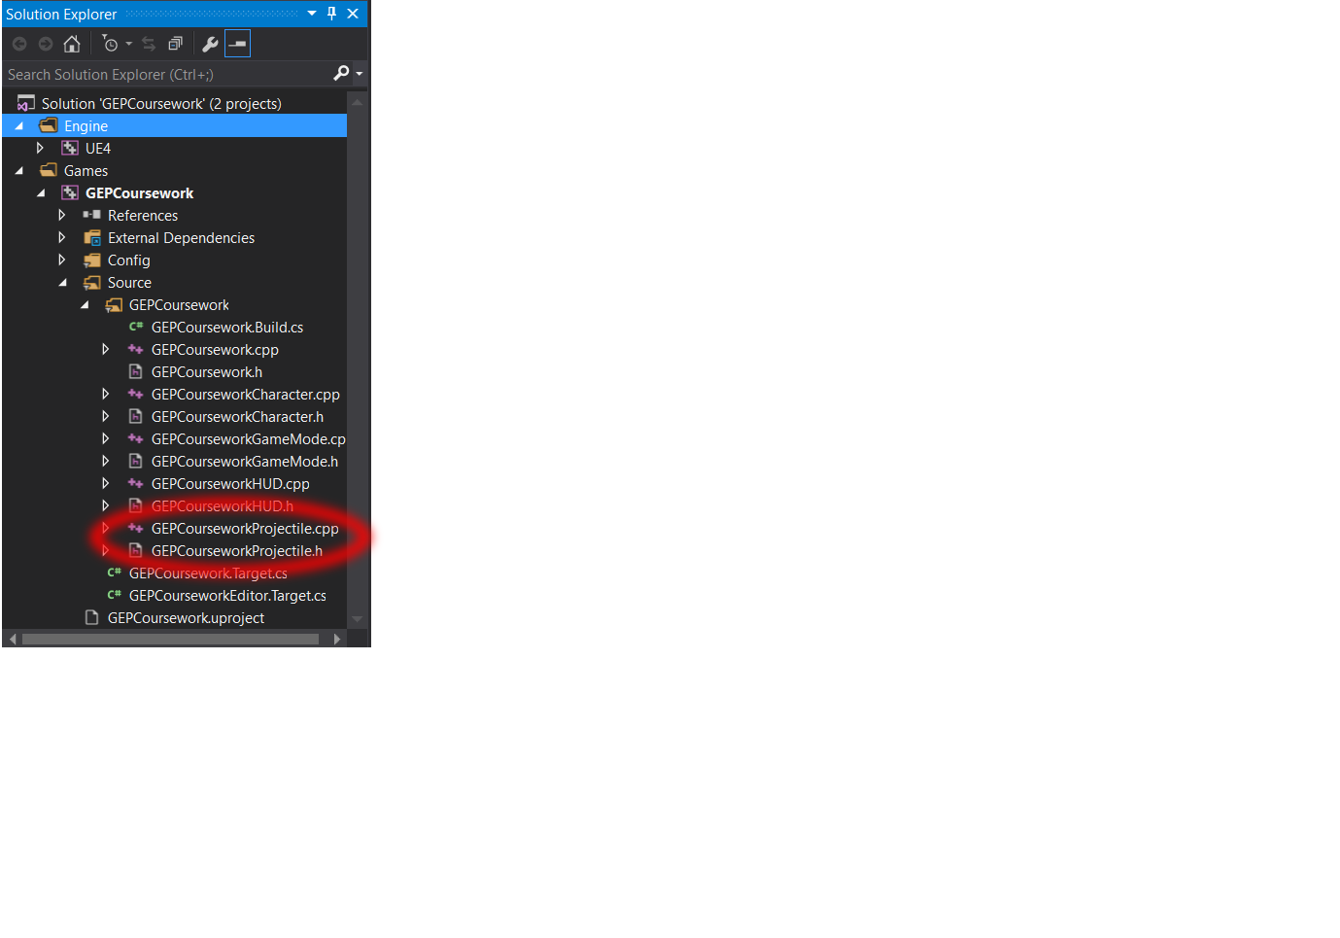

Go to the .cpp file and find the OnHit function at the bottom.

Add the following code

UGameplayStatics::SpawnEmitterAtLocation(GetWorld(), ExplosionEffect, GetActorLocation());

It will look like this:

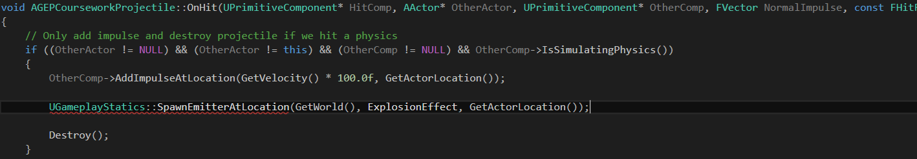

Before this will work we need to include the header for UGameplayStatics.h at the top of the file.

#include "Kismet/GameplayStatics.h"

*Kismet was UDK’s visual scripting language, these gameplay static functions were created for ease of use.*

Now we need to define ExplosionEffect and make it accessible to the editor.

Go into the header file.

Add the following code below the ProjectileMovementComponent

UPROPERTY(EditDefaultsOnly, Category = "FX")

UParticleSystem* ExplosionEffect;

Make sure that your spelling is correct and there is no ; at the end of the UPROPERTY

Forward declare UParticleSystem

It should look like this:

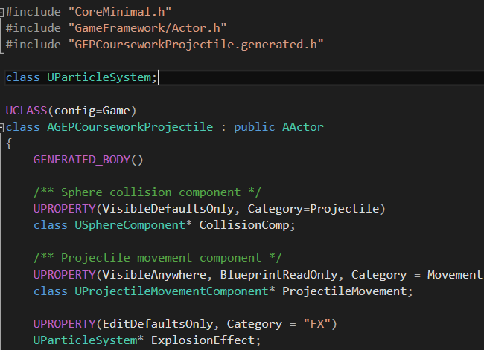

Compile with F7 and the editor should launch on success, if not open it from the project directory.

Navigate to FirstPersonCPP->Blueprints->FirstPersonProjectile and open it by double clicking

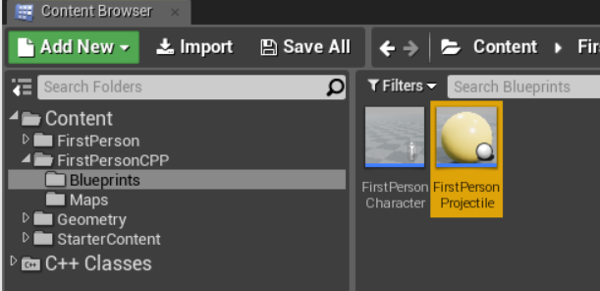

Select Open Full Blueprint Editor

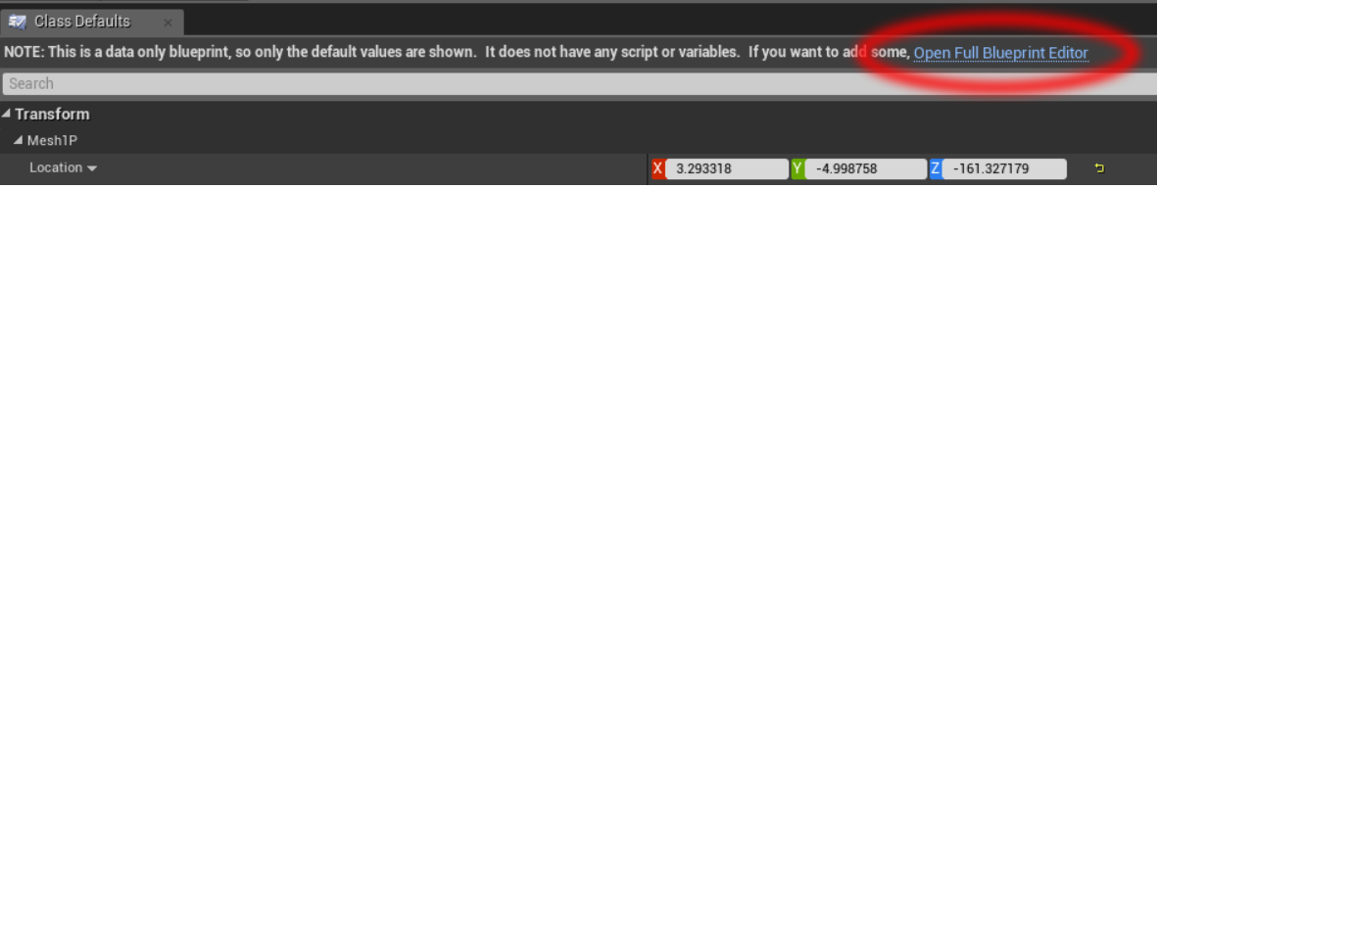

We can now see our exposed particle system called Explosion Effect, use the drop down to select P_Explosion.

**If P_Explosion does not exist** you need to import starter content. Ask me or follow this link: goo.gl/dRjt8V

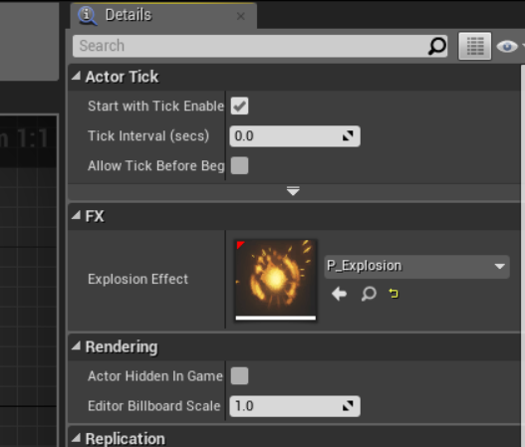

Compile by pressing F7 or selecting the Compile button.

Close this blueprint window and play the game. Explosions should spawn when you hit the boxes.

**Section 4 – The Blueprint Method**

In visual studio, comment out the code we just created and the Destroy() function call inside OnHit

*Else the C++ event will fire first and destroy the actor before the blueprint event.*

Recompile then open up the blueprint editor for the projectile again.

Select the CollisionComp Component and select the + symbol next to the On Component Hit event.

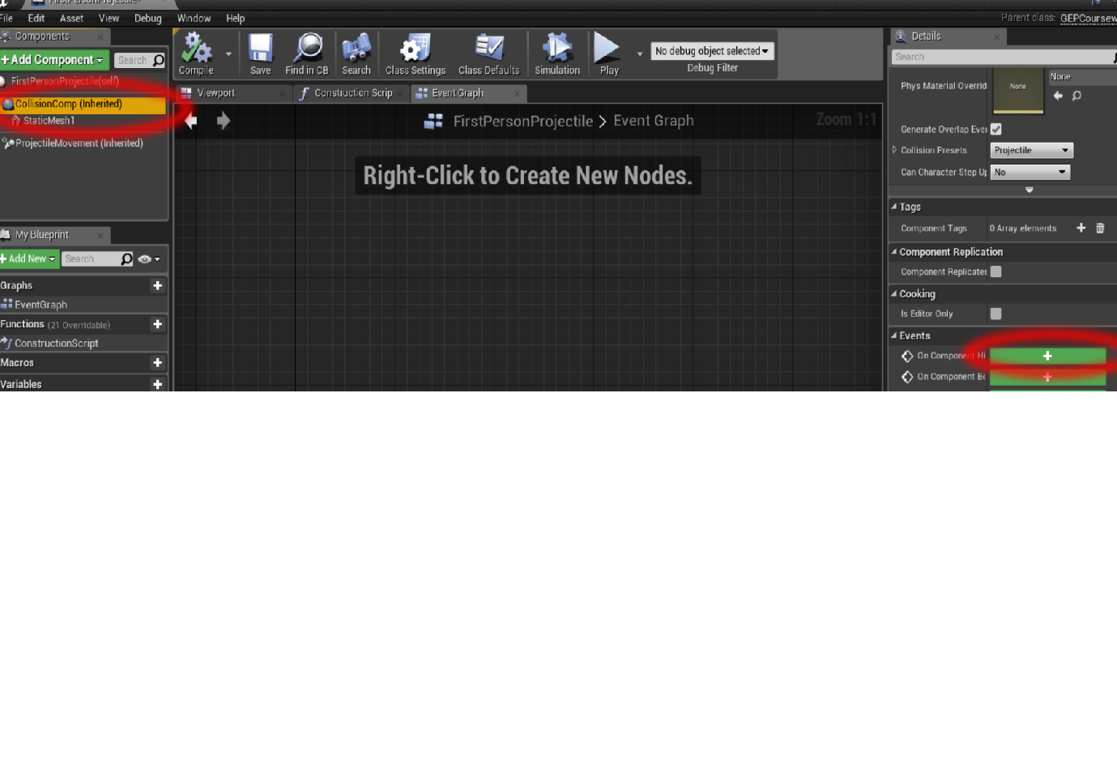

Right click on empty space and type “spawn emit” then select Spawn Emitter at Location. Select P_Explosion from the dropdown under Emitter Template.

Right click and create a GetActorLocation node, drag out of the yellow pin into Location socket on the emitter node.

From the On Component Hit node, drag out of the OtherComp pin and type “Is Simulating Physics”.

Create a Branch node and set it up like this:

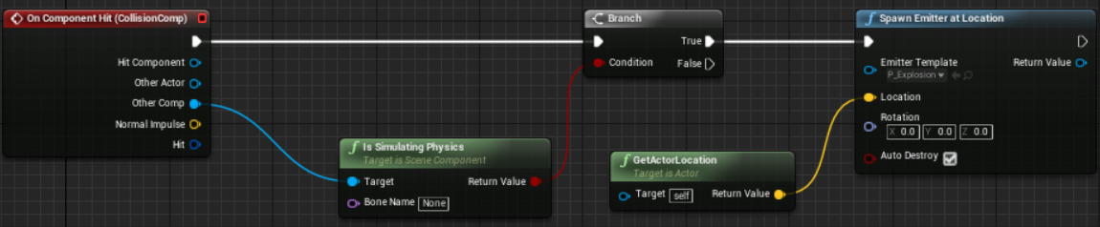

This is essentially doing the same thing that our C++ code was.

**Extra tasks (C++ or Blueprint)**

**Task 1** - Play a sound effect when the projectile hits a box. I recommend Collapse_02.wav

**Task 2** - Change the gun sound effect of the character

**Task 3** – Destroy the cubes when hit